MySQL Challenge

Q1. Query all columns for all American cities in the CITY table with populations larger than 100000. The CountryCode for America is USA.

select * from city

where countrycode = 'USA' and `population` > 100000;

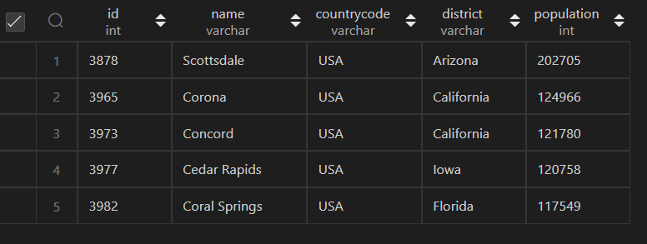

Q2. Query the NAME field for all American cities in the CITY table with populations larger than 120000. The CountryCode for America is USA.

select `name` from city

where countrycode = 'USA' and `population` > 120000;

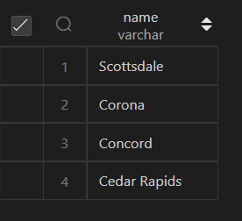

Q3. Query all columns (attributes) for every row in the CITY table.

select * from city;

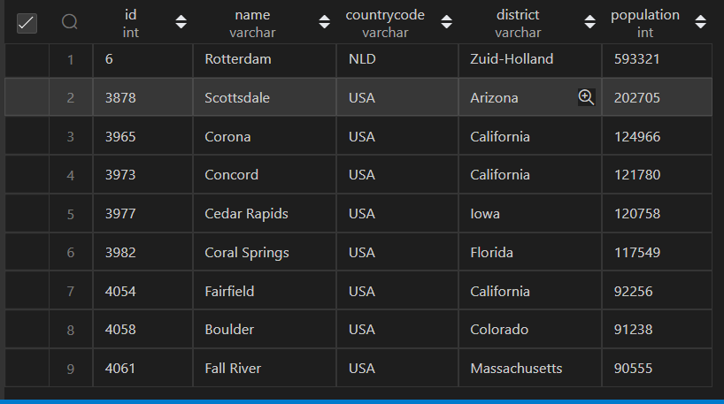

Q4. Query all columns for a city in CITY with the ID 1661

select * from city where id = 1661;

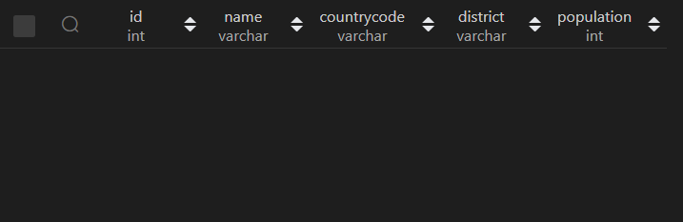

Q5. Query all attributes of every Japanese city in the CITY table. The COUNTRYCODE for Japan is JPN.

select * from city where countrycode = 'JPN';

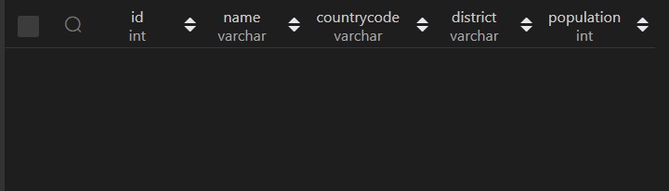

Q7. Query a list of CITY and STATE from the STATION table.

select DISTINCT city, `state` from station;

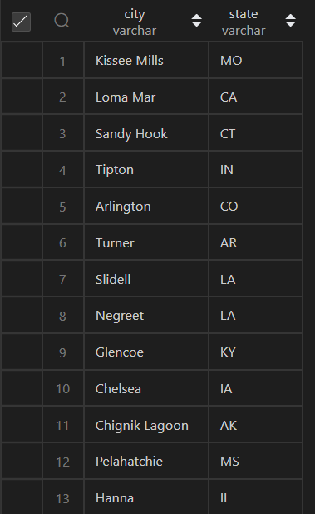

Q8. Query a list of CITY names from STATION for cities that have an even ID number. Print the results in any order, but exclude duplicates from the answer.

select distinct id,city from station where (id % 2) = 0;

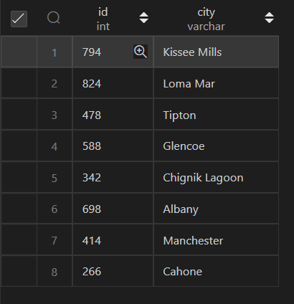

Q9. Find the difference between the total number of CITY entries in the table and the number of distinct CITY entries in the table.

select @distCount := count(DISTINCT city) from station;

select @count := count(city) from station;

select @distCount - @count;



Q10. Query the two cities in STATION with the shortest and longest CITY names, as well as their respective lengths (i.e.: number of characters in the name). If there is more than one smallest or largest city, choose the one that comes first when ordered alphabetically.

select city, LENGTH(city) as name_length_max

from station

where LENGTH(city) = (select max(LENGTH(city)) from station) order by city;

select city, LENGTH(city) as name_length_min

from station

where LENGTH(city) = (select min(LENGTH(city)) from station) order by city;





Q11. Query the list of CITY names starting with vowels (i.e., a, e, i, o, or u) from STATION. Your result cannot contain duplicates.

select distinct city from station

where substr(city,1,1) in ('a','e','i','o','u');

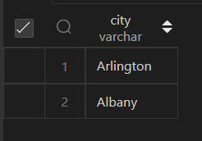

Q12. Query the list of CITY names ending with vowels (a, e, i, o, u) from STATION. Your result cannot contain duplicates.

select distinct city from station

where substr(city,-1,1) in ('a','e','i','o','u');

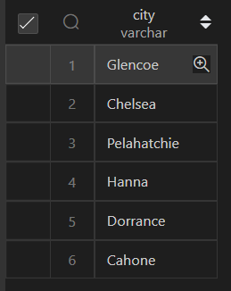

Q13. Query the list of CITY names from STATION that do not start with vowels. Your result cannot contain duplicates.

select distinct city from station

where substr(city,1,1) not in ('a','e','i','o','u');

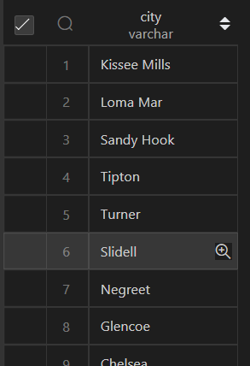

Q14. Query the list of CITY names from STATION that do not end with vowels. Your result cannot contain duplicates.

select distinct city from station

where substr(city,-1,1) not in ('a','e','i','o','u');

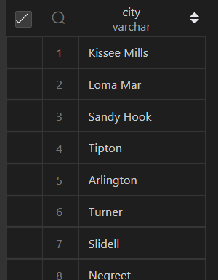

Q15. Query the list of CITY names from STATION that either do not start with vowels or do not end with vowels. Your result cannot contain duplicates.

select distinct city from station

where (substr(city,-1,1) not in ('a','e','i','o','u'))

or

(substr(city,1,1) not in ('a','e','i','o','u'));

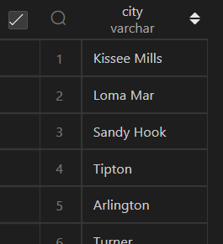

Q16. Query the list of CITY names from STATION that do not start with vowels and do not end with vowels. Your result cannot contain duplicates.

select distinct city from station

where (substr(city,-1,1) not in ('a','e','i','o','u'))

and

(substr(city,1,1) not in ('a','e','i','o','u'));

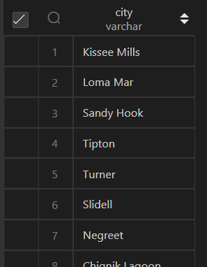

Q17. Write an SQL query that reports the products that were only sold in the first quarter of 2019. That is, between 2019-01-01 and 2019-03-31 inclusive. Return the result table in any order.

select p.*, s.* from product p

inner join sales s on p.product_id = s.product_id

where (s.sale_date BETWEEN  "2019-01-01" and "2019-03-31")

and

(s.sale_date < (select sale_date from sales where product_id = p.product_id and sale_date > "2019-03-31"));



Q18. Write an SQL query to find all the authors that viewed at least one of their own articles. Return the result table sorted by id in ascending order.

select author_id from views

where viewer_id = author_id

group by author_id,article_id

order by author_id;

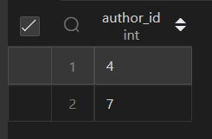

Q19. If the customer's preferred delivery date is the same as the order date, then the order is called immediately; otherwise, it is called scheduled. Write an SQL query to find the percentage of immediate orders in the table, rounded to 2 decimal places.

select sum(case when order_date = customer_pref_delivery_date then 1 else 0 end) as `immediate`,

count(delivery_id) as total_no_order,

round(((sum(case when order_date = customer_pref_delivery_date then 1 else 0 end)/count(delivery_id))*100),2) as persentage

from delivery;

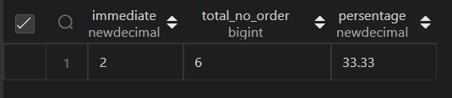

Q20. Write an SQL query to find the ctr of each Ad. Round ctr to two decimal points. Return the result table ordered by ctr in descending order and by ad_id in ascending order in case of a tie.

select

    cal.ad_id,

    case

        when (cal.total_clicks + cal.total_views) = 0 then 0

        else round((total_clicks/(cal.total_clicks + cal.total_views))*100,2)

    end as ctr

from (select

            ad_id,

            sum(case when `action` = 'Clicked' then 1 else 0 end) as total_clicks,

            sum(case when `action` = 'Viewed' then 1 else 0 end) as total_views

        from ads GROUP BY ad_id

     ) cal

     ORDER BY ctr desc;

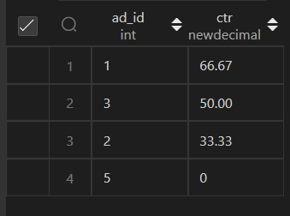

Q21. Write an SQL query to find the team size of each of the employees. Return result table in any order.

select e.employee_id, em.team_size from employee e join

(select team_id, count(*) as team_size from employee group by team_id) em

on e.team_id = em.team_id;

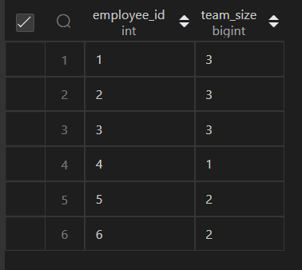

Q22. Write an SQL query to find the type of weather in each country for November 2019. The type of weather is:

● Cold if the average weather_state is less than or equal 15,

● Hot if the average weather_state is greater than or equal to 25, and

● Warm otherwise. Return result table in any order.

select c.country_name,final.* from countries c join

(select

    cal.country_id,

    case

        when cal.avg_weather <= 15 then "Cold"

        when cal.avg_weather >= 25 then "Hot"

        else "Warm"

    end as weather_type

from (select

        country_id,

        avg(weather_state) as avg_weather from weather

        where day like "2019-11-%" GROUP BY country_id

     ) cal

) final

on c.country_id = final.country_id;

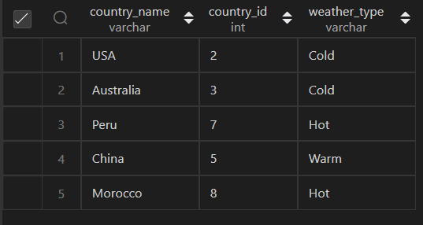

Q23. Write an SQL query to find the average selling price for each product. average_price should be rounded to 2 decimal places. Return the result table in any order.

Average selling price = Total Price of Product / Number of products sold.

Average selling price for product 1 = ((100 * 5) + (15 * 20)) / 115 = 6.96

Average selling price for product 2 = ((200 * 15) + (30 * 30)) / 230 = 16.96

select

    filt.product_id,

    round((sum(filt.total_price)/sum(units)),2) as average_price

    from (select

                p.product_id,

                (p.price * u.units) as total_price,

                u.units

                from prices p join unitsSold u

                on p.product_id = u.product_id and

                u.purchase_date BETWEEN p.`start_date` and p.end_date) filt

group by filt.product_id;

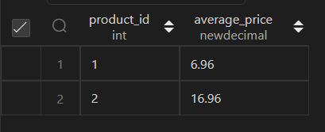

Q24. Write an SQL query to report the first login date for each player. Return the result table in any order.

select

    player_id,

    min(event_date) from activity

group by player_id;

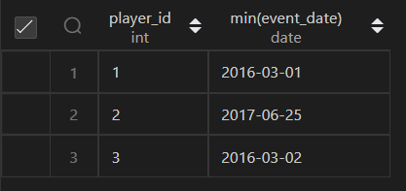

Q25. Write an SQL query to report the device that is first logged in for each player. Return the result table in any order.

select

    tmp.player_id,

    a.device_id

    from (select

            player_id,

            min(event_date) as first_log_in

        from activity

        group by player_id) tmp

    join activity a

    on tmp.player_id = a.player_id

    and a.event_date = tmp.first_log_in;

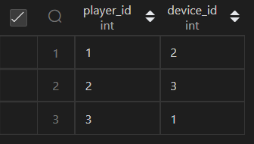

Q26. Write an SQL query to get the names of products that have at least 100 units ordered in February 2020 and their amount. Return result table in any order.

select

    p.product_name,

    tmp.total_unit_sold

    FROM

    (select

        product_id,

        sum(unit) as total_unit_sold

        from orders

    where order_date like "2020-02-%"

    group by product_id) tmp

join products p on p.product_id = tmp.product_id

where total_unit_sold >= 100;

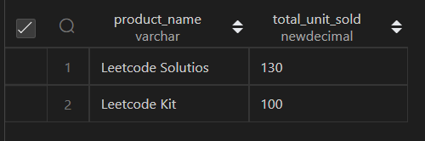

Q27. Write an SQL query to find the users who have valid emails. A valid e-mail has a prefix name and a domain where:

* The prefix name is a string that may contain letters (upper or lower case), digits, underscore '_', period '.', and/or dash '-'. The prefix name must start with a letter.
* The domain is '@leetcode.com'.

Return the result table in any order

select * from users

where mail REGEXP '^[a-zA-Z]+[a-zA-Z0-9_\.\-][*@leetcode\.com](mailto:*@leetcode\.com)';

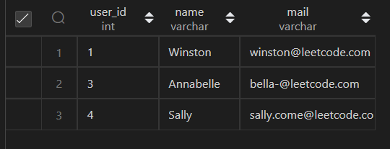

Q28. Write an SQL query to report the customer_id and customer_name of customers who have spent at least $100 in each month of June and July 2020. Return the result table in any order.

select

    customer_id,

    `name`

from Customers

where customer_id =

    (select s.customer_id from

        (select

            final.customer_id,

            final.month_total as 5th_mnth_total,

            lead(final.month_total,1,0)

            over(partition by final.customer_id) as 6th_mnth_total

            from

            (select

            tmp.customer_id,

            sum(tmp.price) as month_total,

            month(tmp.order_date) as mnth

        from (select

                ord.customer_id,

                (ord.quantity * p.price) as price,

                ord.order_date

            from Product p

            join (select

                    customer_id,

                    product_id,

                    quantity,

                    order_date

                from Orders

                where month(order_date) in (6,7)) ord

            on p.product_id = ord.product_id) tmp

        group by month(tmp.order_date),tmp.customer_id

        order by tmp.customer_id) final) s

    where s.5th_mnth_total >= 100 and s.6th_mnth_total >= 100);

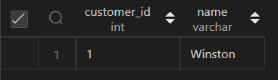

Q29. Write an SQL query to report the distinct titles of the kid-friendly movies streamed in June 2020. Return the result table in any order.

select

    distinct c.title

from TVProgram t join

Content c

on c.content_id = t.content_id

where c.Kids_content = 'Y'

and c.content_type = "Movies"

and t.program_date like "2020-06-%";



Q30. Write an SQL query to find the npv of each query of the Queries table. Return the result table in any order.

select n.id,n.year,n.npv

from NPV n join  Queries q

on n.id = q.id and n.year = q.year

order by n.id;

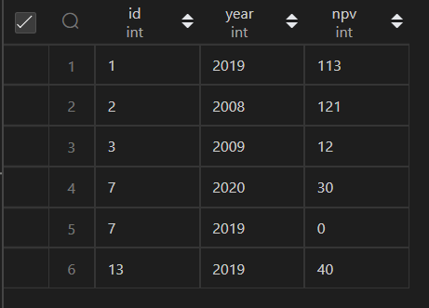

Q32. Write an SQL query to show the unique ID of each user, If a user does not have a unique ID replace just show null. Return the result table in any order.

select

    eu.unique_id,

    e.name from Employees e

    left join EmployeeUNI eu

on e.id = eu.id;

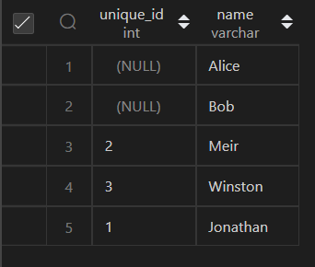

Q33. Write an SQL query to report the distance travelled by each user. Return the result table ordered by travelled_distance in descending order, if two or more users travelled the same distance, order them by their name in ascending order.

select

    u.name,

    COALESCE(s.travelled_distance,0) as travelled_distance

from Users u left join

    (select

        user_id,

        sum(distance) as travelled_distance

    from Rides

    group by user_id) s

on u.id = s.user_id

order by s.travelled_distance desc, name;

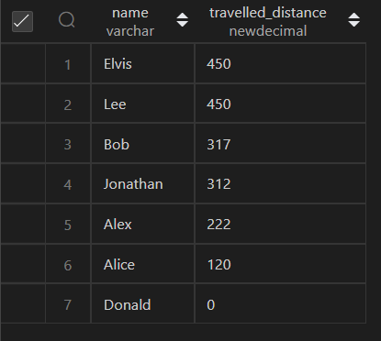

Q35. Write an SQL query to:

* Find the name of the user who has rated the greatest number of movies. In case of a tie, return the lexicographically smaller user name.
* Find the movie name with the highest average rating in February 2020. In case of a tie, return the lexicographically smaller movie name.

The query result format is in the following example.

Q38. Write an SQL query to find the id and the name of all students who are enrolled in departments that no longer exist. Return the result table in any order.

select s.id, s.name from Departments d right join Students s

on

d.id = s.department_id

where d.id is null;

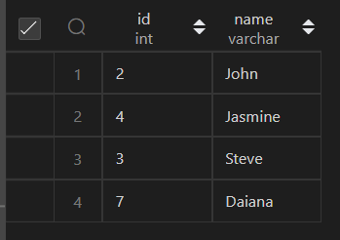

Q39. Write an SQL query to report the number of calls and the total call duration between each pair of distinct persons (person1, person2) where person1 < person2. Return the result table in any order.

with test as (select

    from_id,to_id,duration,

    case

        when  from_id < to_id then concat(from_id,'-',to_id)

        else reverse(concat(from_id,'-',to_id))

    end as ar

from Calls)

select

    substr(ar,1,1) as person1,

    substr(ar,-1,1) as person2,

    count(*) as call_count,

    sum(duration) as total_duration

     from test group by ar;

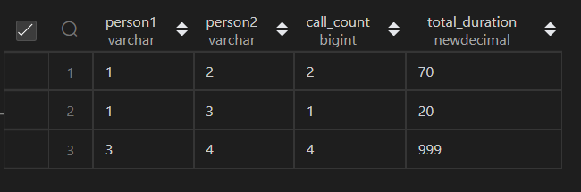

Q41. Write an SQL query to report the number of cubic feet of volume the inventory occupies in each warehouse. Return the result table in any order.

select

    w.name,

    sum((p.Width * p.Length * p.Height)*w.units) as volume

from Warehouse w join Products p

on w.product_id = p.product_id

GROUP BY w.name;

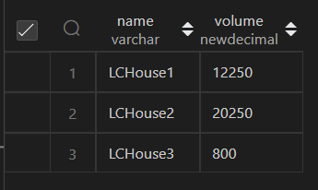

Q42. Write an SQL query to report the difference between the number of apples and oranges sold each day. Return the result table ordered by sale_date.

select

    s.sale_date,

    (s.total_salse_ap - s.total_salse_or) as diff from

    (select

    sale_date,

    sum(case when fruit = 'apples' then sold_num else 0 end) as total_salse_ap,

    sum(case when fruit = 'oranges' then sold_num else 0 end) as total_salse_or

from Sales

GROUP BY sale_date) s order by s.sale_date;

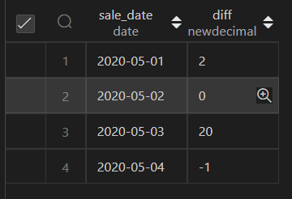

Q43. Write an SQL query to report the fraction of players that logged in again on the day after the day they first logged in, rounded to 2 decimal places. In other words, you need to count the number of players that logged in for at least two consecutive days starting from their first login date, then divide that number by the total number of players.

select

    (sum(case when s.day_count > 1 then 1 else 0 end) / count(DISTINCT s.player_id)) as diff

from

    (select *,

        count(*) over(partition by player_id order by event_date

                        range BETWEEN interval '1' day preceding

                        and current row) as day_count

    from Activity) s;

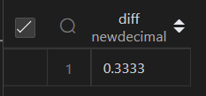

Q44. Write an SQL query to report the managers with at least five direct reports. Return the result table in any order.

with test as (select *,

    count(*) over(partition by managerId) as reports_count from Employee)

select e.name from Employee e join

(select managerId from test where reports_count >= 5 group by managerId) s

on e.id = s.managerId;

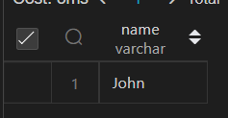

Q45. Write an SQL query to report the respective department name and number of students majoring in each department for all departments in the Department table (even ones with no current students). Return the result table ordered by student_number in descending order. In case of a tie, order them by dept_name alphabetically

with stu_count as (select d.dept_name, s.student_id from Department d left join

Student s on d.dept_id = s.dept_id)

select

    dept_name,

    COALESCE(count(student_id),0) as student_count

from stu_count group by dept_name order by student_count desc, dept_name;

